**Indian Institute of Technology Patna**

**Dept. of Electrical Engineering**

**Bihta, Patna, Bihar – 801106**

**Name -** Madan Kumar Jha

**Roll No. –** 2411EE23

**Project** – Classical PLL

**Current Starved VCO**

A **Voltage-Controlled Oscillator (VCO)** in a Phase-Locked Loop (PLL) is a key component responsible for generating an output frequency that varies based on an applied control voltage. The PLL continuously adjusts this voltage to lock the VCO's frequency and phase to a reference signal, enabling precise frequency synthesis and clock recovery. The VCO’s frequency deviation is determined by its gain factor (Hz/V), making it crucial for maintaining stability and minimizing jitter in communication systems, microprocessors, and RF applications. Its ability to dynamically adjust frequency makes it essential for frequency modulation, demodulation, and synchronization in digital and analog circuits.

**Circuit Diagrams:**

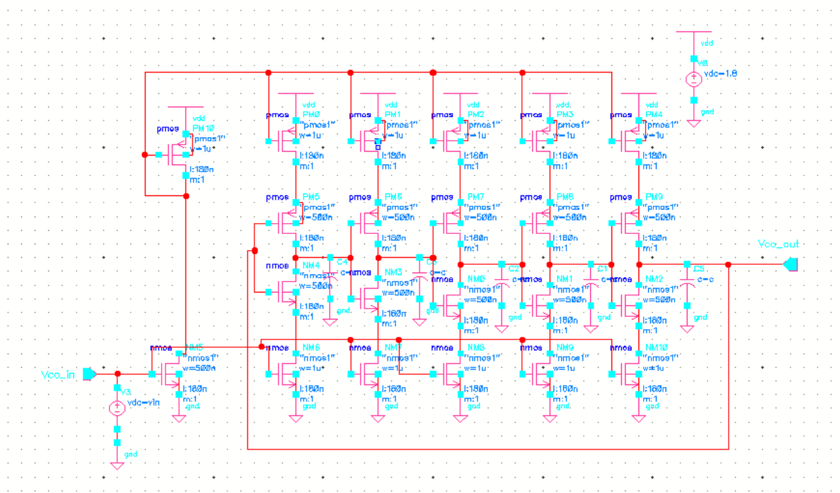

**Fig 1(a):** Current – starved ring Voltage Controlled Oscillator

**Result:**

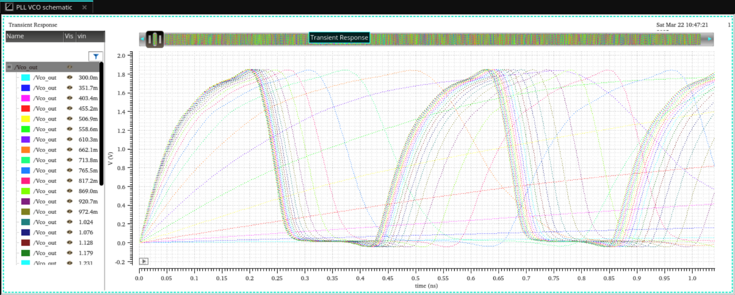

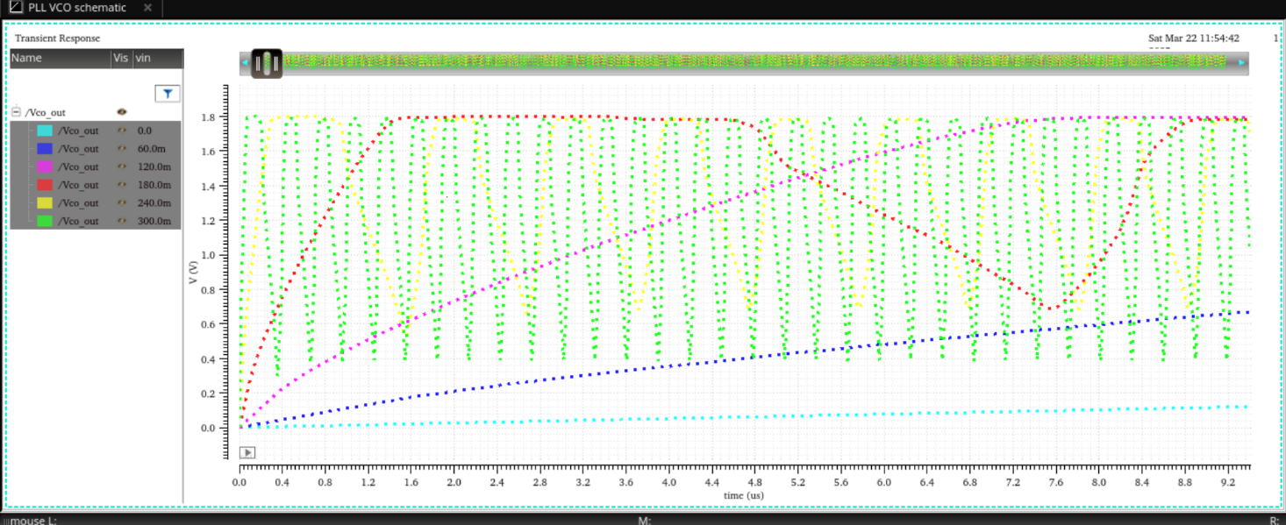

**Fig 2:** Output waveform of VCO using Parametric analysis

|  |  |
| --- | --- |
| Voltage (V) | Frequency(GHz) |
| 0 | 0 |
| 0.06 | 0.000012 |
| 0.12 | 0.000052 |
| 0.18 | 0.00027 |
| 0.24 | 0.00097 |
| 0.3 | 0.0032 |
| 0.3517 | 0.0089 |
| 0.4034 | 0.0245 |
| 0.4452 | 0.0619 |
| 0.5069 | 0.149 |
| 0.5586 | 0.3246 |
| 0.6103 | 0.5971 |
| 0.6621 | 0.9399 |
| 0.7138 | 1.2623 |
| 0.7655 | 1.499 |
| 0.8172 | 1.746 |
| 0.869 | 1.875 |
| 0.9207 | 1.981 |
| 0.9724 | 2.052 |
| 1.024 | 2.109 |
| 1.076 | 2.153 |
| 1.128 | 2.156 |
| 1.179 | 2.221 |
| 1.231 | 2.223 |
| 1.283 | 2.224 |
| 1.334 | 2.271 |
| 1.386 | 2.302 |
| 1.438 | 2.316 |
| 1.49 | 2.32 |
| 1.541 | 2.32 |
| 1.593 | 2.32 |
| 1.645 | 2.32 |
| 1.697 | 2.32 |
| 1.748 | 2.32 |
| 1.8 | 2.32 |
|  |  |